Assignment 3:

Johannes Mämmelä
15027782
johannes.mammela@tuni.fi

- Introduction:
There are some functional differences between fetus and adult hearts. After birth, the left ventricle pumps blood to body and the right pumps the blood to the lungs for acquiring oxygen. For the fetals, oxygen is supplied by the placenta and both ventricles are pumping blood to the body. For this purpose, there are two shunts, called the foramen ovale and the ductus arteriosus that link the outgoing vessels of both ventricles. This allows blood to go to the right atrium and and bypass the pulmonary circulation. After birth the foramen ovale closes with the first breaths and the ductus arteriosus partially closes in 10 to 15 hours after birth and after three weeks it is completely closed. Fetus’ heart rate is in the range 110 to 160 beats per minute while their mother’s heart rate is significantly lower when resting. While mechanical function of the fetus heart differs from an adult heart beat-to-beat electrical activity is rather similar. [1]
While recording fetus’ ECG signal, it is always interrupted by mother’s heart. It is so important to separate baby’s ECG and mother’s ECG from each other so we can monitor the action of baby’s heart and notice if something is wrong. Then doctors are allowed to intervene and improve fetal outcome, decrease miscarriages an minimize unnecessary obstetric interference.

- Methods
One way to separate fetus’ and mother’s ECGs is adaptive filtering. An adaptive filter is a system with a linear filter that has a transfer function controlled by variable parameters and a means to adjust those parameters according to an optimization algorithm. The closed loop adaptive filter uses feedback in the form of an error signal to refine its transfer function. The sketch of the recording set-up is presented in figure 1.

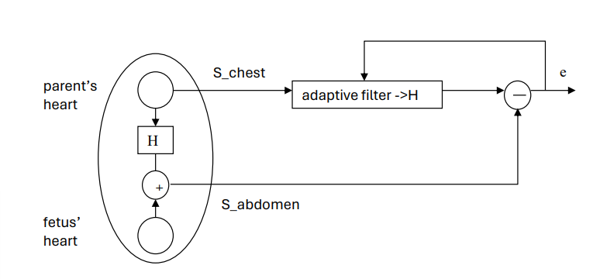
Figure 1: The sketch of recording set-up

In figure 1, S_chest is the measured ECG signal of parent’s chest and S_abdomen is the measured signal from parent’s abdomen. H is the transfer function and e is the output signal, will approximate the fetus ECG signal. The aim of this exercise is to define the transfer function with starting parameters. The idea is to define good starting parameters N and delta where N is filter order and delta is step size number for the least mean square function. After that we create a loop which goes through every integer from filter order to the length of abdomen signal and calculates the error signal between chest and abdomen signals, computes the transfer function, and updates the filter coefficients before moving to the next segment of the signal.
To find the right starting parameters N and delta we have to test our adaptive filter. For that purpose, we generate the code that uses our filter and plots the filtered signal and the filter’s frequency response. With that code we must test different parameter values and study which are giving the best results.

- Results
3.1 Parent’s and the fetus’ ECG
First, we can plot the original signal measured from parent’s abdominal area. There is part of it presented below.
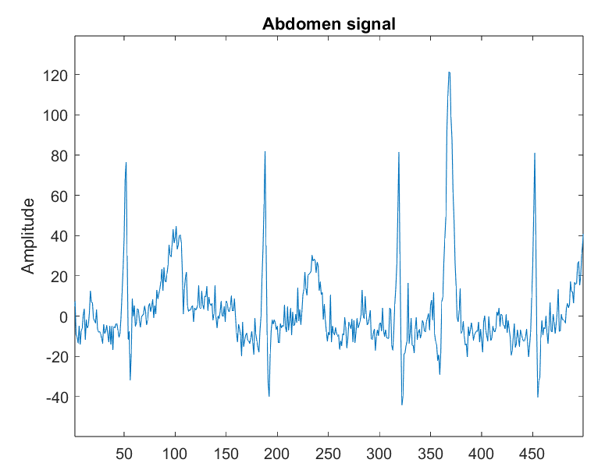
Figure 2: Abdomen signal
By looking at that picture, it is noticeable that there are four quite similar periods. Those periods are from fetus’ heartbeats. There can be clearly seen QRS-complexes, P-wave before it and T-wave after it. However, there is also very strong peak located between index numbers 350 and 400 which looks strange in the picture. That peak looks like it could be is from parent’s heart. It could be parent’s QRS complex. By plotting the signal measured from parent’s chest, we can check if there is similar peak at the place and make sure about that. The same index range from the signal measured from parent’s chest presented below.
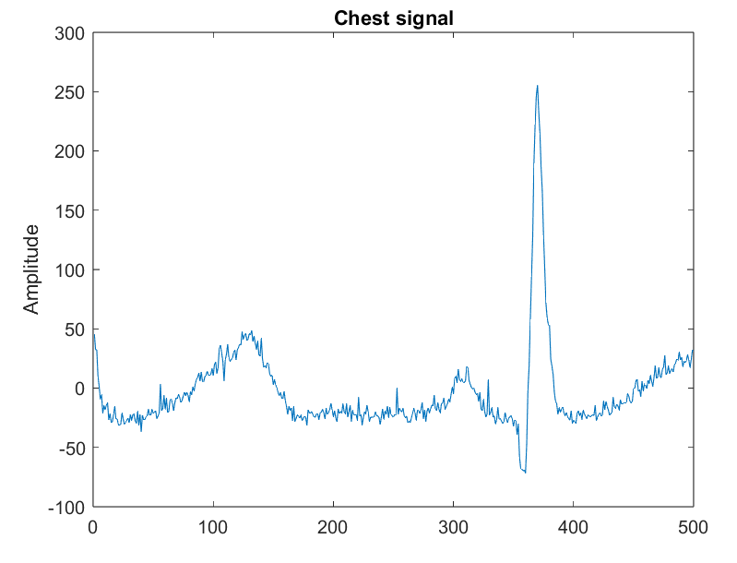
As we can see, there is also strong peak at the same index range than abdomen signal has. So, we can state that peak is parent’s QRS complex. Also, we can notice that there fits approximately one heat beat at the same range while abdomen signal has four. As we know, fetus heart rate is much bigger than parent’s one, we can also state that the rest of the peaks in abdomen signal are fetus’ QRS complexes. By comparing both signals, it is also noticeable that the parents first P-wave and the fetus’ first T-wave are overlapping. That explains why the first T-wave in abdomen signal is stronger than other ones.
Based on the above, it is clearly seen that the fetus’ ECG is interwoven by the parent’s ECG.

  - Adaptive filtering
The next step is to find the right values to our parameters. We know that delta must be very small number so let’s set it to 0.00001 and test what happens to the extracted fetus signal and frequency response with different starting order number. First, let’s test what happens when we set filter order value to 1. When we plot the extracted fetus signal and compare it to the abdomen signal, it is seen that the parent’s peak is weaker but is still clearly there. Frequency response is only straight line, so it does not look correct. Small filter order has not enough parameters to sufficiently model the frequency response required to differentiate between the desired and undesired components of the input signals. When we increase the filter order value to 7, the parent’s peak in the extracted fetus signal is even weaker but large order number overfits the input signals by capturing noise and irrelevant details. With order number 3 we get the best compromise.
Now, when order number is set to value 3, let’s change the delta value. If we use very small delta value, the extracted fetus signal does not differ from abdomen signal. With small steps, adjustments to the filter coefficients are very small and the adaptive filter is quite slow. On the other hand, if we use big delta value, filter is too fast and hops over the important data like fetus’ QRS peaks. The best result is gotten when delta value is 0.000002.
The filter also depends on the number of iterations. The error signal approaches the desired signal by every iteration time, but the output signal does not significantly change anymore when iterated enough. So, big number of iteration times is unnecessary. To these signals in this assignment, 7 iteration times is enough. The extracted fetus signal and filter’s frequency response with filter order 3, delta value 0.000002 and 7 iteration times plotted below in figures 4 and 5.
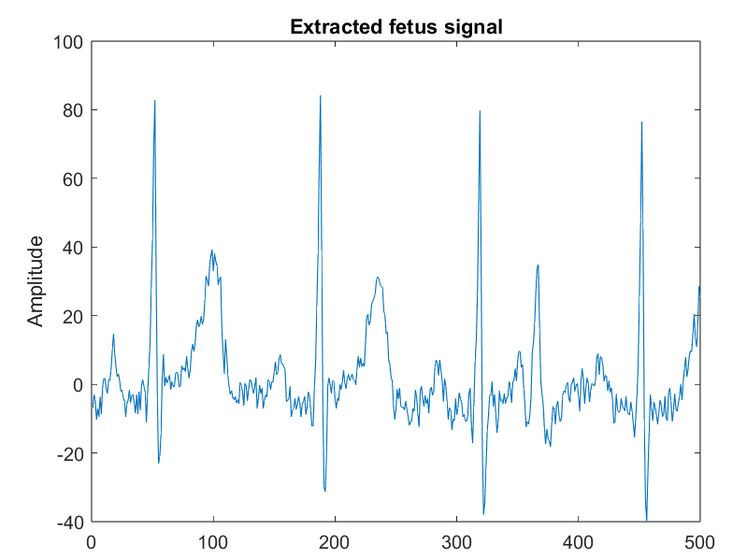
Figure 4: Extracted fetus signal
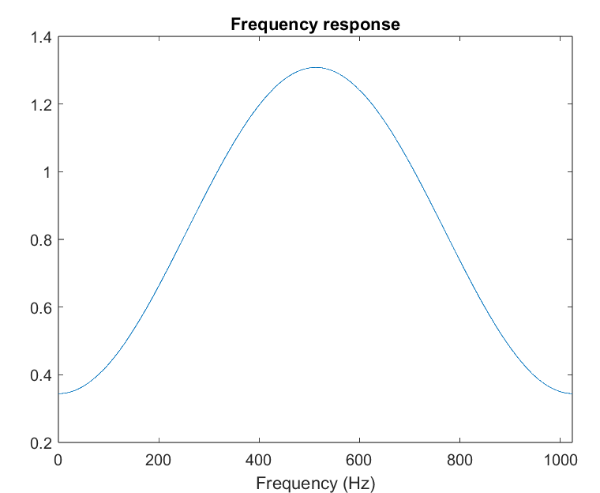
Figure 5: Frequency response

As seen from the figure 4, the parent’s QRS complex is gone and the peak at that place looks more like fetus’ T-wave. The frequency response shows how the filter amplifies or attenuates different frequencies. It seems like our filter amplifies well the mid frequencies of the frequency scale and the small and high frequencies are well attenuated. That is good thing because error signal includes KIRJOTA LOPPUUUUN!! JA PUHTAAKSI!!

- Conclusion
This assignment demonstrates well and concretely what we can do with adaptive filtering and how useful tool it is specifically in fetal ECG monitoring. Key finding of my study is the successful separation of fetal and parent ECGs. I personally learned a lot more about creating functions in Matlab and how much different parameters and values of these effect the functionality of filter. Also I learned new information about fetal heart action and how it differs from adult person.

5. Resources
[1] Reza Sameni, Gari D. Clifford. National Librabry of Medicine. “A Review of Fetal ECG Signal Processing; Issues and Promising Directions” (2010), [Referred 2.5.2024]. https://www.ncbi.nlm.nih.gov/pmc/articles/PMC3100207/
LISSÄÄ AINAKI WIKIPEDIA ADAP.FILTTERI JA RAPSAOHJEET + TYÖOHJE

- Matlab codes
